EC2 dashboard showing instance

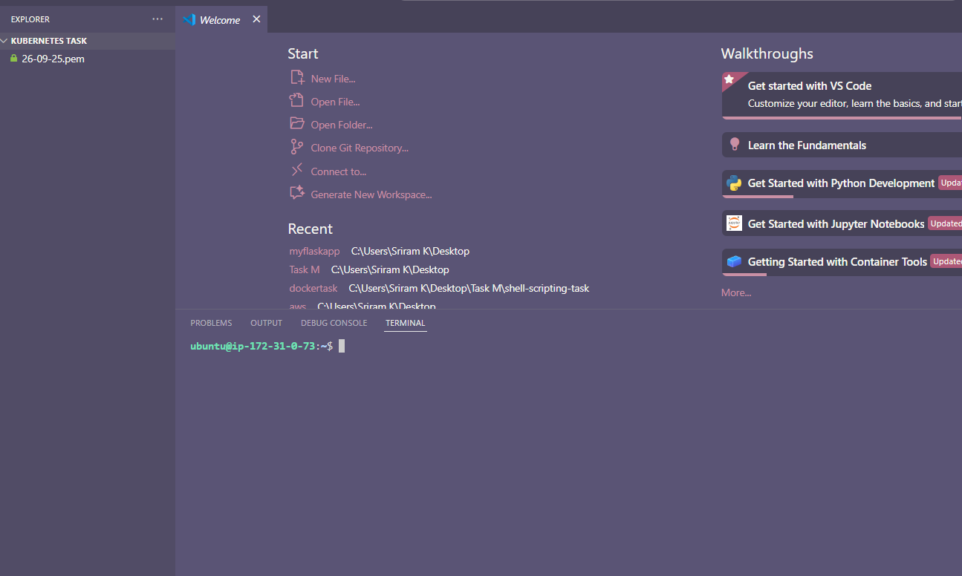

Install Docker

Mini kube

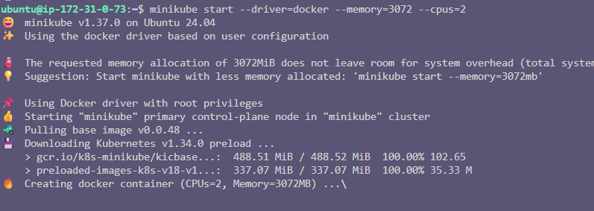

Kubernetes

